HASEEB ULLAH (51784) BSE4A
ASSIGNMENT 1

Task No. 1:
Draw State chart diagram of course enrolment.
UI SnapShot:
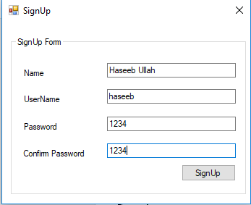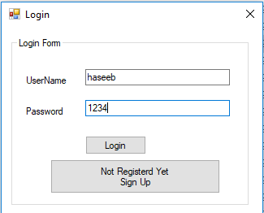
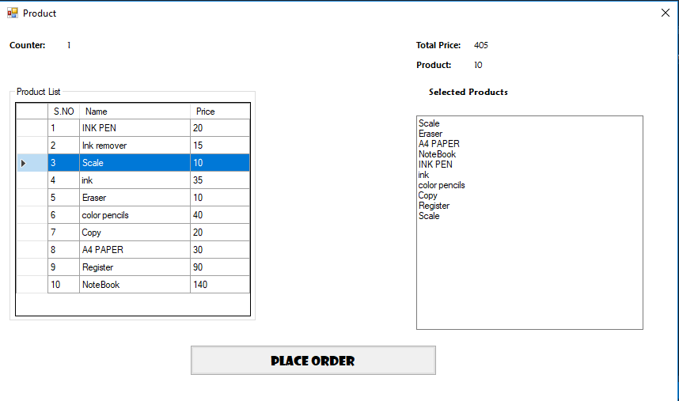

Product DLL:
namespace lab5dll
{
public class Product
{
public static List<Tuple<string, string, string>> list = new List<Tuple<string, string, string>>();
public static List<Tuple<string, int>> products = new List<Tuple<string, int>>();
static int counter = 0,pcounter=0;static bool flag = false;
public int totalprice = 0;
public int PCounter()
{
pcounter++;
return pcounter;
}
public int Counter()
{
counter++;
return counter;
}
public int Add(string name,int price)
{
products.Add(new Tuple<string, int>(name,price));
totalprice += price;
return PCounter();
}
public int login(string user,string pass)
{
if (!flag)
{ list.Add(new Tuple<string, string, string>("Haseeb Ullah", "Admin", "97,100,109,105,110")); flag = true; }
foreach (var element in list)
{
if ((element.Item2 == user)&&(decrypt(element.Item3)==pass))
return 1;
}
return 0;
}
public string decrypt(string pas)
{
string a = pas;
string[] arr=a.Split(',');
string data = "";
for (int i = 0; i < arr.Length; i++)
{
try
{
data += Convert.ToChar(Convert.ToInt32(arr[i].ToString()));
}
catch (Exception e) { }
}
return data;
}
public string encrypt(string pas)
{
string encrypted="";
char[] arr = password.ToCharArray();
foreach(char a in arr)
{
encrypted += Convert.ToInt32(a).ToString();
encrypted += ','.ToString();
}
return encrypted;
}
public int SignUp(string name,string user,string password)
{
if (!flag)
{ list.Add(new Tuple<string, string, string>("Haseeb Ullah", "Admin", "97,100,109,105,110")); flag = true; }
foreach (var element in list)
{
if (element.Item2 == user)
return 0;
}

password = encrypt(password);
list.Add(new Tuple<string, string, string>(name,user,password));
return 1;
}
}
}
Order Form:
namespace lab5
{
public partial class FinalProduct_Form : Form
{
Product obj1 = new Product();
public FinalProduct_Form()
{
InitializeComponent();
Counterlabel2.Text = obj1.Counter().ToString();
dataGridView1.Columns[0].Width = 40;
dataGridView1.Columns[1].Width = 140;
dataGridView1.Columns[2].Width = 75;
insert();
dataGridView1.SelectionMode = DataGridViewSelectionMode.FullRowSelect;
dataGridView1.MultiSelect = false;
dataGridView1.RowPrePaint += new DataGridViewRowPrePaintEventHandler(dgv_RowPrePaint);
}
int c = 1;
void insert()
{
dataGridView1.Rows.Add(c++, "INK PEN", 20);
dataGridView1.Rows.Add(c++, "Ink remover", 15);
dataGridView1.Rows.Add(c++, "Scale", 10);
dataGridView1.Rows.Add(c++, "ink", 35);
dataGridView1.Rows.Add(c++, "Eraser", 10);
dataGridView1.Rows.Add(c++, "color pencils", 40);
dataGridView1.Rows.Add(c++, "Copy", 20);
dataGridView1.Rows.Add(c++, "A4 PAPER", 30);
dataGridView1.Rows.Add(c++, "Register", 90);
dataGridView1.Rows.Add(c++, "NoteBook", 140); }
private void dgv_RowPrePaint(object sender, DataGridViewRowPrePaintEventArgs e)
{
e.PaintParts &= ~DataGridViewPaintParts.Focus;
}

private void Orderbutton1_Click(object sender, EventArgs e)
{
MessageBox.Show("Order Placed Successfully!", "Lab 5", MessageBoxButtons.OK, MessageBoxIcon.Information);
this.Close();

}
void insertp()
{
Pricelabel3.Text = obj1.totalprice.ToString();
SProducttextBox1.Text = "";
foreach (var element in Product.products)
{
string a = element.Item1;
SProducttextBox1.Text += "" + a + Environment.NewLine;
}
}

private void dataGridView1_DoubleClick(object sender, EventArgs e)
{
Productlabel.Text=obj1.Add(dataGridView1.Rows[dataGridView1.CurrentRow.Index].Cells[1].Value.ToString(),Convert.ToInt32(dataGridView1.Rows[dataGridView1.CurrentRow.Index].Cells[2].Value)).ToString();
insertp();
}
}
}

Signup Form:
namespace lab5
{
public partial class SignUp : Form
{
public SignUp()
{
InitializeComponent();
}

private void logbutton1_Click(object sender, EventArgs e)
{
int check = 0;
if (Spass1textBox2.Text == SConfirmtextBox1.Text)
{
Product obj = new Product();
check = obj.SignUp(SNametextBox2.Text, SUsertextBox1.Text, Spass1textBox2.Text);
this.Hide();
LogINForm obj1 = new LogINForm();
obj1.Show();
if(check==0)
MessageBox.Show("UserName Alredy Taken Try Different", "Lab5", MessageBoxButtons.OK, MessageBoxIcon.Error);
else
MessageBox.Show("Account Created SuccessFully!", "Lab5", MessageBoxButtons.OK, MessageBoxIcon.Information);
}
else
MessageBox.Show("Password Not Match Please Retype it", "Lab5", MessageBoxButtons.OK, MessageBoxIcon.Error);
}
}
}

Login Form:
namespace lab5
{
public partial class LogINForm : Form
{
public LogINForm()
{
InitializeComponent();
regbutton2.Text = "Not Registerd Yet" + Environment.NewLine + " Sign Up";
}
private void button1_Click(object sender, EventArgs e)
{
int check = 0;
Product obj1 = new Product();
check=obj1.login(usertextBox1.Text, passtextBox2.Text);
if (check == 0)
MessageBox.Show("Password And UserName Is In Correct", "Lab5", MessageBoxButtons.OK, MessageBoxIcon.Error);
else
{
FinalProduct_Form obj = new FinalProduct_Form();
obj.Show();
MessageBox.Show("Login SuccessFully!", "Lab5", MessageBoxButtons.OK, MessageBoxIcon.Information);
}
}
private void regbutton2_Click(object sender, EventArgs e)
{
this.Hide();
SignUp obj = new SignUp();
obj.Show();
}
}
}

Class Diagram:
Component Diagram:
Object Diagram:

